**Shweta Sampath Kumar – Assignment 2**

**PART 1: Relational Modeling**

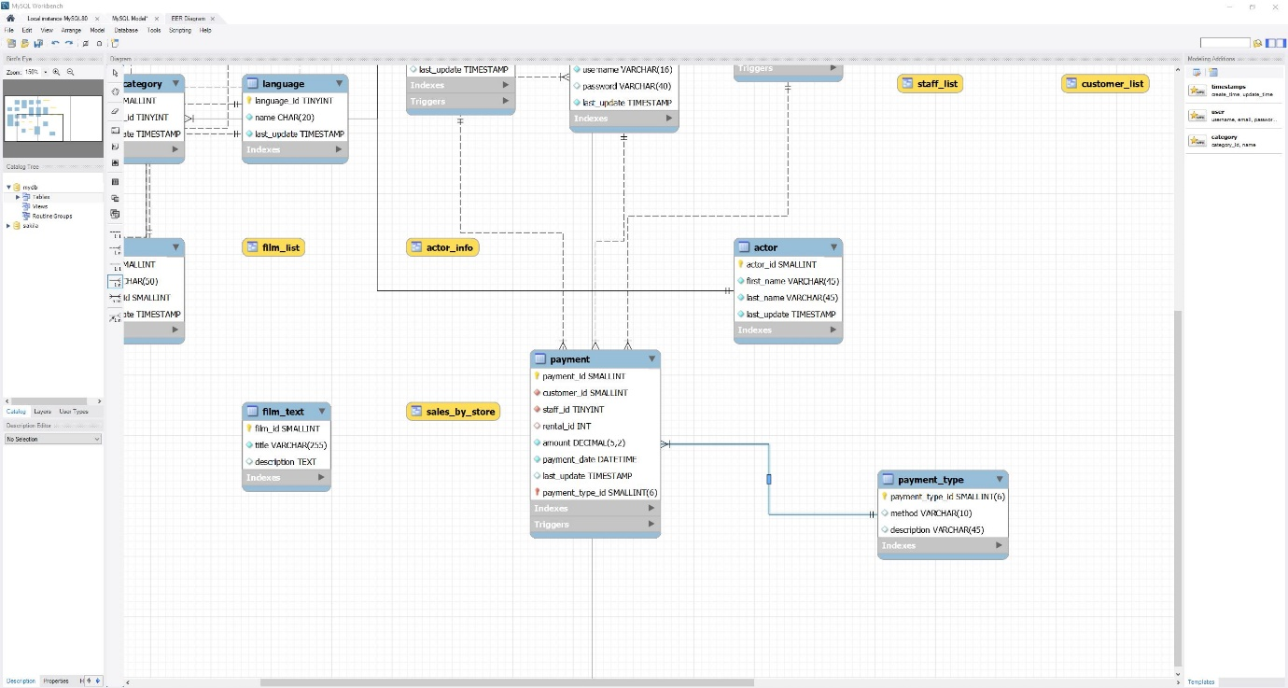

**Table Name:**Payment

|  |  |  |  |
| --- | --- | --- | --- |
| **Field (Attributes)** | **Primary Key (Y/N)** | **Foreign Key (Y/N)** | **Related Table(s) and Cardinality between tables** |
| **payment\_id** | Y | N | NA |
| **customer\_id** | N | Y | payment; 1:m; customer |
| **staff\_id** | N | Y | payment; 1:m; staff |
| **rental\_id** | N | Y | payment; 1:m; rental |
| **amount** | N | N | NA |
| **payment\_date** | N | N | NA |
| **last\_update** | N | N | NA |
| **payment\_type\_id** | Y | Y | payment; 1:m; payment\_type |

*(continued on next page…)*

## ****PART 3: Data Modeling:****C:\Users\Administrator\Downloads\Data Engineering Platforms\Assignment 2\movie_ERD.png

## ****PART 4: Design Document:****

1. A short summary of design considerations:
   * Database type – Relational database
   * Type/number of users:
     + Who will be using this database, and how many people (roughly) do you estimate will be using it?
       1. *The staff of the movie studio will be using this database like the analytics team or the IT teams.*
       2. *Depending on the movie studio size, it may range from 20 to maximum ~50 users.*
   * Need for distributed databases:
     + Based on how the business will use it, do you think they should implement a distributed database? *I believe that a distributed database should be implemented as each movie will be shown across multiple locations. A distributed database will help track the ticket sales across these locations at the same time.*
   * Data security considerations:
     + How will you control access to the database?  Will all users have the same access? *With the help of database access control, the number of users and their level of access can be controlled. For example:*
       1. *Staff responsible for logging the data will have edit access most probably through a portal. When information is to be extracted by them, a view only access can be provided.*
       2. *The analytics team will have view only access that also of specific tables like movie\_has\_theatre*
       3. *The databse management team will grant access as per the requirements.*
   * Data privacy considerations:
     + Is there any sensitive personal information in the database that needs to be restricted or specially processed? *Personal information is present in the database of producers or actors which is sensitive information. Such information can be only accessed by the database managers or can be viewed by teams with additional security constraints in place.*
   * Data integrity considerations:
     + How will your data model ensure data integrity and protect against anomalies?
       1. *My model is currently normalized to endure that insertion, deletion & modification anomalies do not occur. Along with that, I’ve set data types and lengths to ensure that the data gathered follows the required constraints to be homogenous.*
       2. *The data should be monitored frequently, checked for duplicates and backup should be created in case of an adverse event like servers are destroyed due to natural calamity or some data is deleted by mistake.*
       3. *Access is controlled regularly to ensure only required members are using it and their actions are logged.*